A project report on

AN ADVANCED MODULATION TECHNIQUE FOR CASCADED MULTILEVEL INVERTER OF HIGHER VOLTAGE LEVEL AND LOWER TOTAL HARMONIC DISTORTION

*SUBMITTED IN PARTIAL FULFILLMENT OF THE REQUIREMENTS*

*FOR THE AWARD OF THE DEGREE OF*

**BACHELOR OF TECHNOLOGY**

**IN**

**ELECTRICAL AND ELECTRONICS ENGINEERING**

Submitted

By

S.KAVYA SREE (10F01A02A8) M.NANCHARIAH (10F01A0277)

K.AYYAPPA SWAMI (11F05A0211) CH.NAGABUSHNAM (11F05A0203)

Under the esteemed guidance of

G.KALADHAR,M.Tech,(ph.D)

Assistant Professor

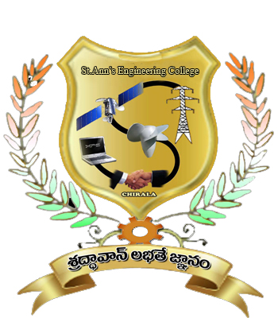

**DEPARTMENT OF ELECTRICAL AND ELECTRONICS ENGINEERING**

**ST.ANN’S COLLEGE OF ENGINEERING AND TECHNOLOGY**

*(Accredited twice by NBA &IE(I) & NAAC With ‘A’ GRADE approved by AICTE, NewDelhi &**Permanentl***y** *Affiliated to JNTU,KAKINADA)*

**CHIRALA, A.P.**

**2010-2014**

DEPARTMENT OF ELECTRICAL AND ELECTRONICS ENGINEERING

**ST.ANN’S COLLEGE OF ENGINEERING & TECHNOLOGY,CHIRALA**

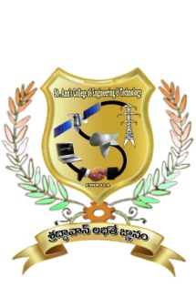

**CERTIFICATE**

This is to certify that the project report entitled **“**AN ADVANCED MODULATION TECHNIQUE FOR CASCADED MULTILEVEL INVERTER OF HIGH VOLTAGE LEVEL AND LOWER TOTAL HARMONIC DISTORTION**”** is the bonafide work done by Mr./Ms……………………. with Regd no:**………………** submitted in the partial fulfillment of the requirements for the award of Bachelor of Technology in **ELECTRICAL & ELECTRONICS ENGINEERING** of during the academic year (2013-2014). The results embodied in this project report have not been submitted to any other University or Institute for the award of any degree.

***Project Guide Head of the Department***

**Mr. G.KALADHAR, M.Tech(Ph.D). Mr. S.V.D.ANIL KUMAR, M.Tech(Ph.D)**

Assistant Professor, Department of EEE,Associate Professor, Department of EEE,

**External Examiner**

**DECLARATION**

I hereby declare that the project entitled, “AN ADVANCED MODULATION TECHNIQUE FOR CASCADED MULTILEVEL INVERTER OF HIGH VOLTAGE LEVEL AND LOWER TOTAL HARMONIC DISTORTION” was carried out and written by us under the guidance of Assistant Professor of Electrical and Electronics Engineering, St. Ann’s College of Engineering & Technology, Chirala. This work has not been previously formed the basis for the award of any degree or diploma or certificate nor has been submitted elsewhere for the award of any degree or diploma.

**Place:**

**Date:**

**PROJECT ASSOCIATES:**

**S.KAVYA SREE (10F01A02A8)**

**M.NANCHARAIAH (10F01A0277)**

**K.AYYAPPA SWAMI (11F05A0211)**

**CH.NAGA BHUSHANAM (11F05A0203)**

**ACKNOWLEDGEMENT**

It is with immense pleasure that we would like to express our indebted gratitude to our guide who has guided us a lot and encouraged us in every step of the project work. His valuable moral support and guidance throughout the project helped us to a greater extent.

We feel elated to thank our Head of the Department **Mr.S.V.D** **ANIL KUMAR,** inspiring us all the way and arranging all the facilities and resources needed for our project.

We would like to thank our principal **Dr. C.S. RAO** for providing support and stimulating environment. We would like to express our gratitude to the management of **St. Ann’s College of Engineering and Technology** for providing us with a pleasant environment and excellent laboratory facilities.

We express our sincere thanks to the teaching staff, Non-teaching staff for providing us the required impetus to complete this project.

Finally we wish to thank all our classmates and friends who directly or indirectly helped us to complete this project.